FULL STACK APPLICATION DEVELOPMENT (week 1)
TASK-1
- Create table using DDL command:
Create table:

CREATE TABLE student (
name VARCHAR(20),
reg_id INT,
contact INT
);
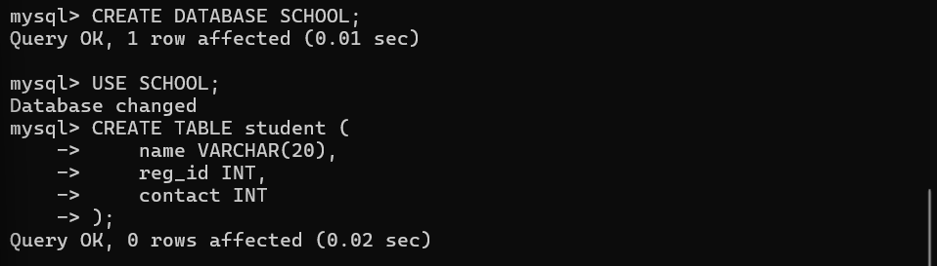

Alter add:

ALTER TABLE student ADD address VARCHAR(200);

Alter default data add:

ALTER TABLE student ADD dob DATE DEFAULT '02-FEB-2010';
Alter drop:
ALTER TABLE student DROP address;

Alter rename:
ALTER TABLE student RENAME COLUMN name TO student_name;

Alter Modify:
ALTER TABLE student MODIFY student_name VARCHAR(30);

Rename table:
RENAME student TO student_info;

Truncate table:
TRUNCATE TABLE student_info;

Drop table:
DROP TABLE student_info;

- DDL Constrains:
Null command:
CREATE TABLE teacher (
teacher_id INT NULL,
teacher_name VARCHAR(255) NULL,
subject VARCHAR(50)
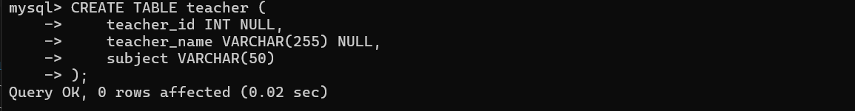
);

Not null command:
CREATE TABLE teacher (
teacher_id INT NOT NULL,
teacher_name VARCHAR(255) NOT NULL,
subject VARCHAR(50) NOT NULL
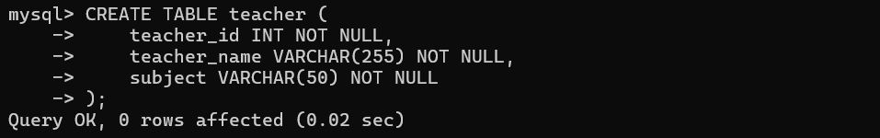
);

Check command:
CREATE TABLE student (
reg_id INT NOT NULL,
student_name VARCHAR(50),
age INT CHECK (age >= 5)
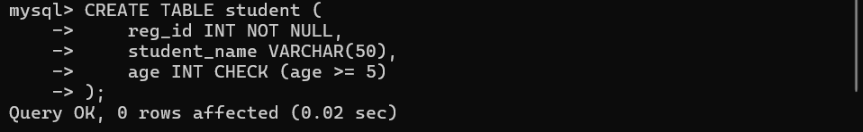
);

Unique:
CREATE TABLE student (
reg_id INT UNIQUE,
student_name VARCHAR(50),
contact INT
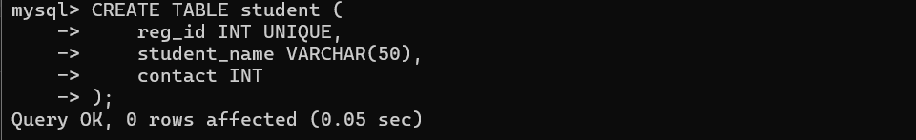
);

Primary key:
CREATE TABLE student (
reg_id INT PRIMARY KEY,
student_name VARCHAR(50),
age INT
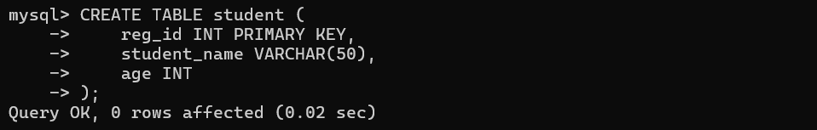
);

Foreign Key:
CREATE TABLE marks (
mark_id INT PRIMARY KEY,
reg_id INT,
subject VARCHAR(50),
marks INT,
FOREIGN KEY (reg_id) REFERENCES student(reg_id)
);
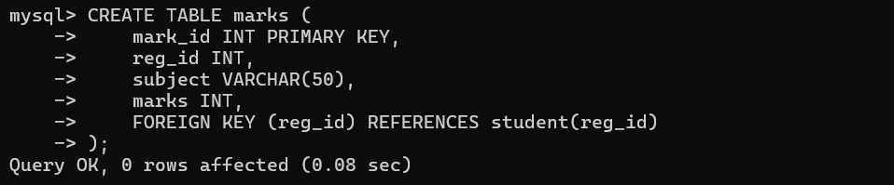
Default:
CREATE TABLE attendance (
attendance_id INT PRIMARY KEY,
reg_id INT,
status VARCHAR(10) DEFAULT 'Present'
);
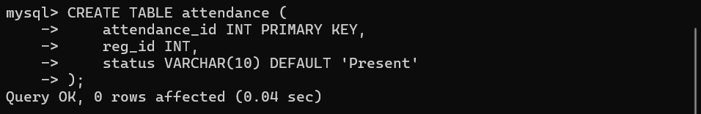
index:
CREATE INDEX idx_student_name ON student(student_name);
- DML Quries:
insert command:

INSERT INTO student VALUES (101, 'Rahul', 12);

INSERT INTO student (reg_id, student_name) VALUES (102, 'Anu');

INSERT INTO student VALUES (103, 'Kiran', NULL);

INSERT INTO attendance VALUES (1, 101, DEFAULT);
update command:
UPDATE student SET student_name = 'Arjun' WHERE reg_id = 101;
UPDATE student SET contact = 9876543210 WHERE reg_id = 102;
Delete command:
DELETE FROM student WHERE reg_id = 103;
DELETE FROM student;

TASK-2
- Aggregation function:
SELECT SUM(marks) FROM marks;
SELECT AVG(marks) FROM marks;
SELECT COUNT(reg_id) FROM student;
SELECT MAX(marks) FROM marks;
SELECT MIN(marks) FROM marks;
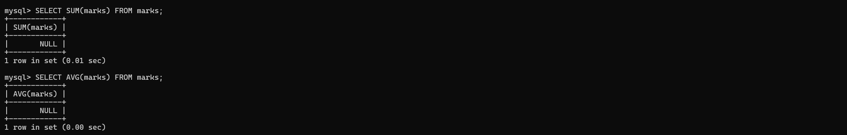
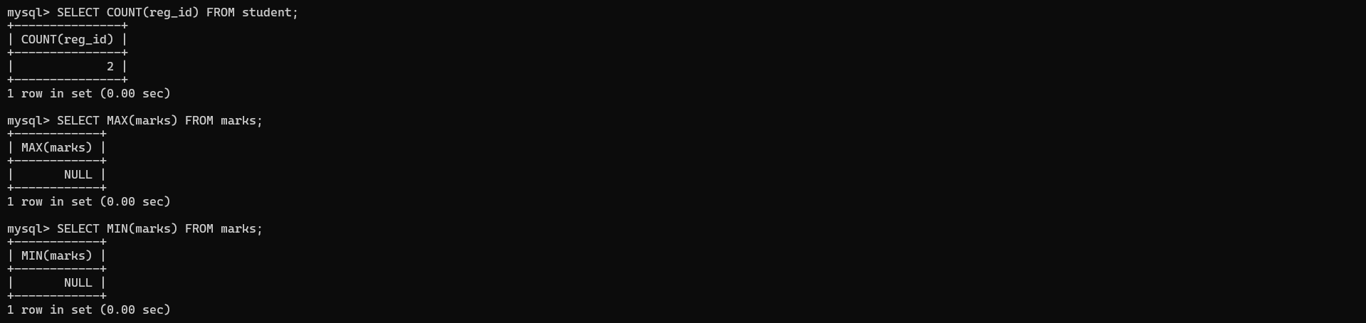
- Clause:
SELECT COUNT(marks) FROM marks WHERE marks >= 50;
Like:
SELECT student_name FROM student WHERE student_name LIKE 'A%';
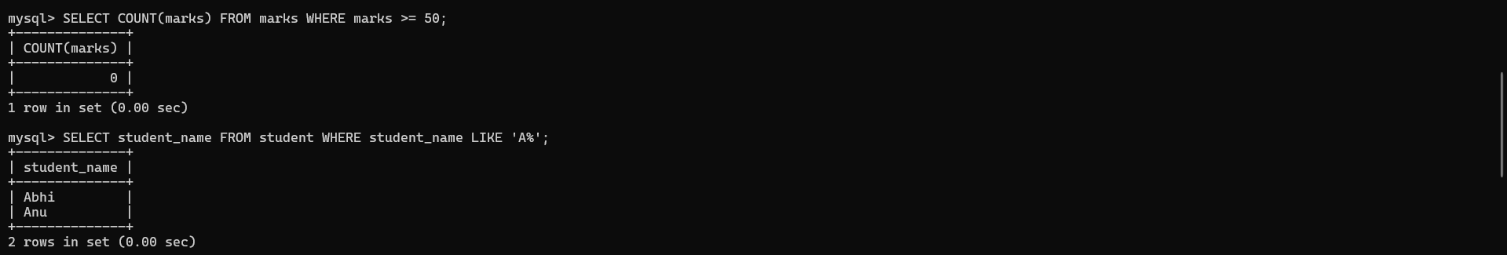
Distinct:
SELECT DISTINCT subject FROM marks;
Group by:
SELECT reg_id, COUNT(subject)
FROM marks
GROUP BY reg_id;
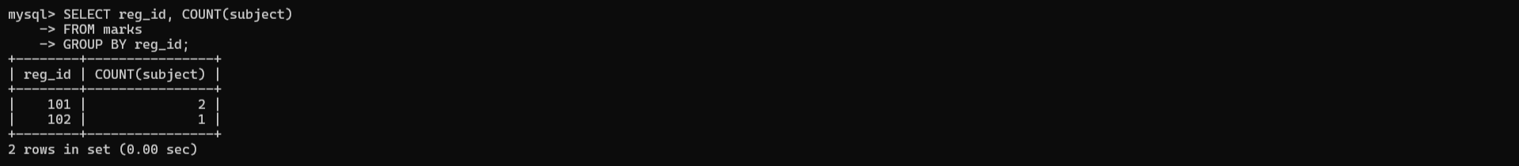
Order by:
SELECT student_name FROM student ORDER BY student_name;

- Nested Queries:
SELECT student_name
FROM student
WHERE reg_id = (
SELECT reg_id FROM marks
WHERE marks = (SELECT MAX(marks) FROM marks)
);
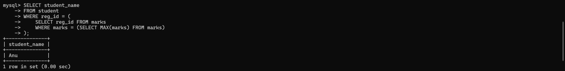
TASK-3

- Inner join:
SELECT student.student_name, marks.subject, marks.marks
FROM student
INNER JOIN marks ON student.reg_id = marks.reg_id;
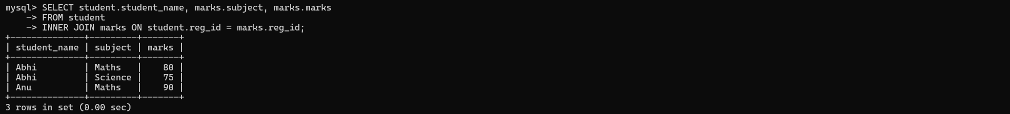
- Left join:
SELECT student.student_name, marks.marks
FROM student
LEFT JOIN marks ON student.reg_id = marks.reg_id;
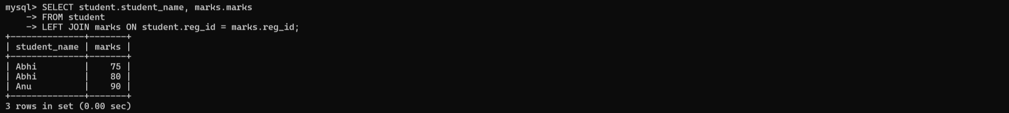
- Right join:
SELECT student.student_name, marks.marks
FROM student
RIGHT JOIN marks ON student.reg_id = marks.reg_id;
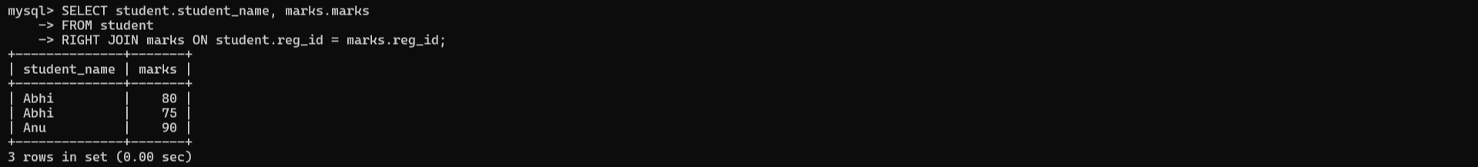
- Cross join:
SELECT student.student_name, teacher.teacher_name
FROM student
CROSS JOIN teacher;
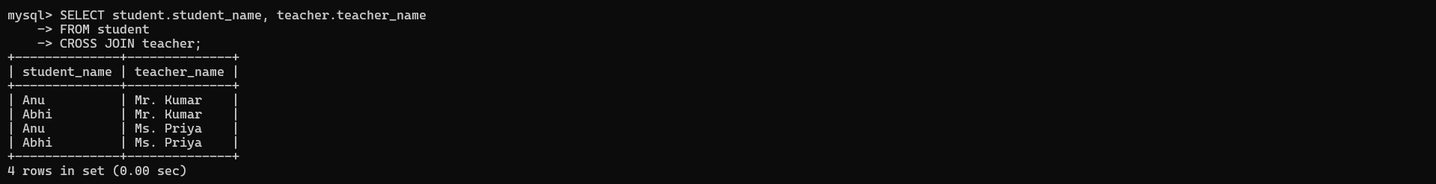

TASK-4

- Simple Stored Procedure (Print message):
DELIMITER //

CREATE PROCEDURE welcome_msg()
BEGIN
SELECT 'Welcome to School Management System' AS Message;
END //

DELIMITER ;
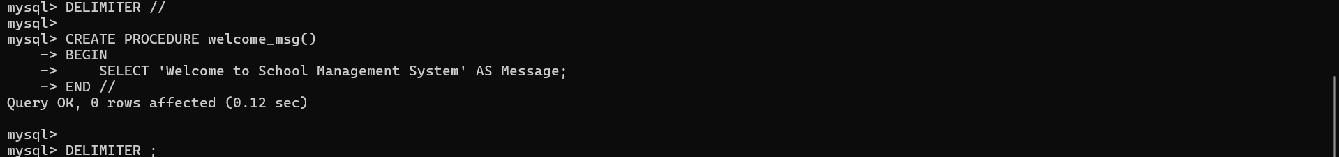
Call procedure:
CALL welcome_msg();
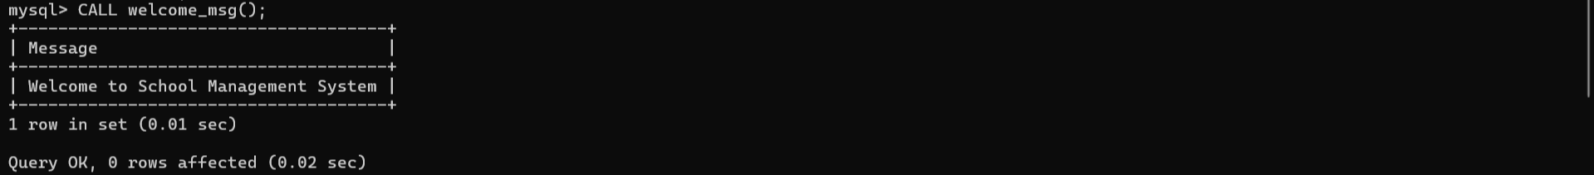
- Procedure with IF–ELSE (Pass / Fail):
DELIMITER //

CREATE PROCEDURE check_result(IN marks INT)
BEGIN
IF marks >= 50 THEN
SELECT 'PASS' AS Result;
ELSE
SELECT 'FAIL' AS Result;
END IF;
END //

DELIMITER ;
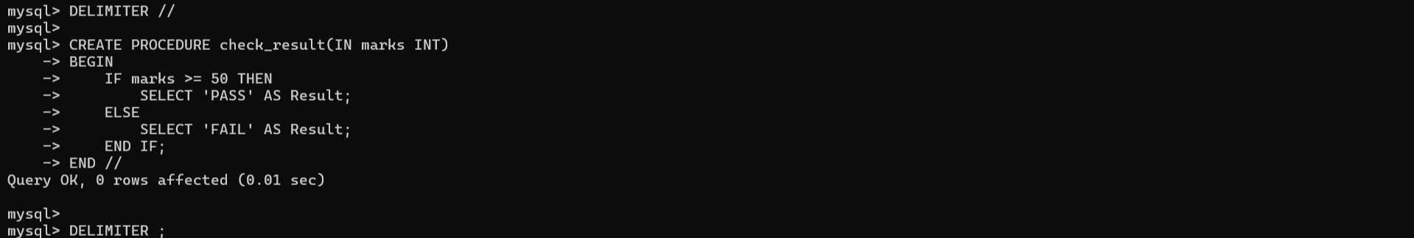
Call:
CALL check_result(75);
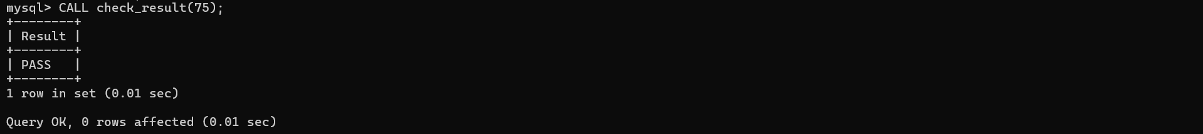
- Loop Program (Print numbers 1 to 5):
DELIMITER //

CREATE PROCEDURE print_numbers()
BEGIN
DECLARE i INT DEFAULT 1;

WHILE i <= 5 DO
SELECT i AS Number;
SET i = i + 1;
END WHILE;
END //

DELIMITER ;
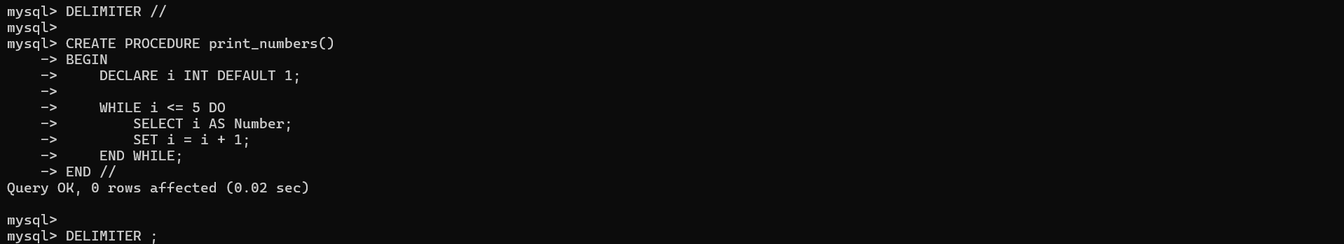
Call:
CALL print_numbers();
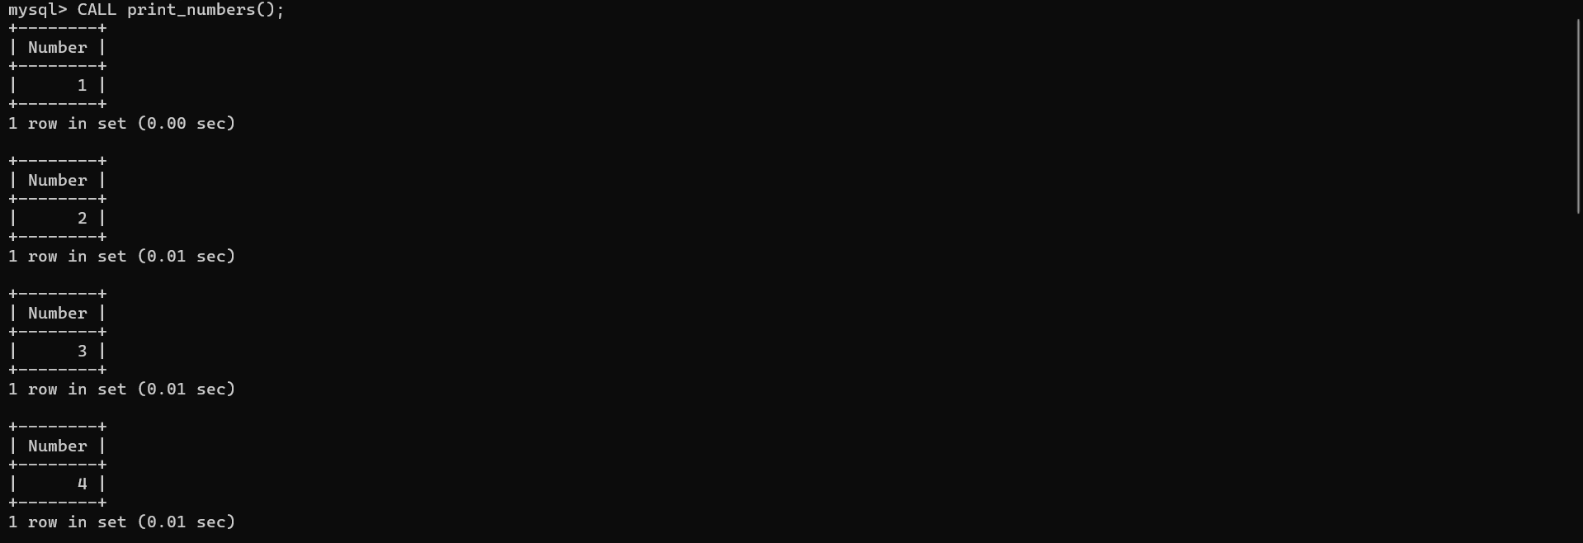
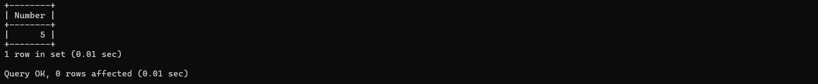
- Function (Return Total Marks):
DELIMITER //

CREATE FUNCTION total_marks(m1 INT, m2 INT)
RETURNS INT
DETERMINISTIC
BEGIN
RETURN m1 + m2;
END //

DELIMITER ;
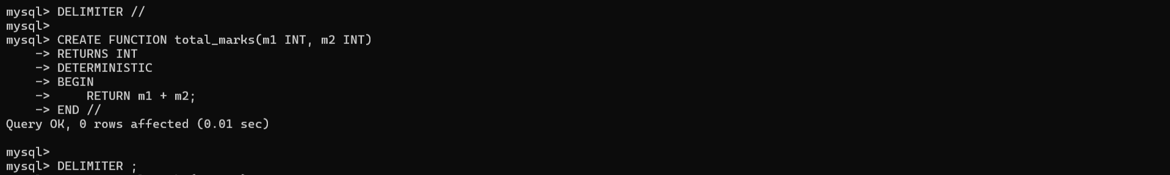
Use function:
SELECT total_marks(40, 50);

TASK-5

- Trigger (Phone number validation):
DELIMITER //

CREATE TRIGGER phone_check
BEFORE INSERT ON student
FOR EACH ROW
BEGIN
IF LEFT(NEW.contact,1) NOT IN ('9','8','7') THEN
SIGNAL SQLSTATE '45000'
SET MESSAGE_TEXT = 'Enter correct phone number';
END IF;
END //

DELIMITER ;
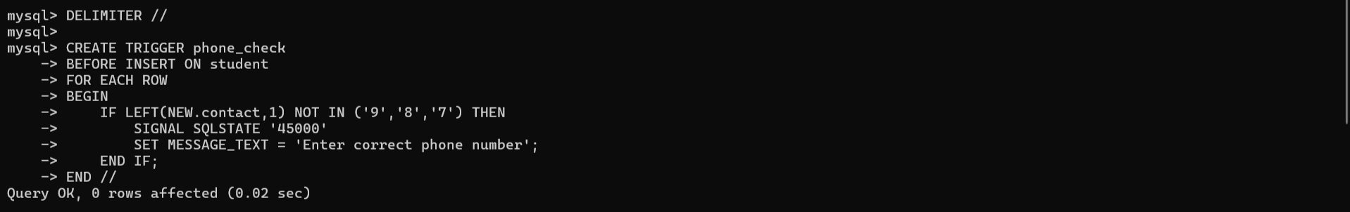
Test:
INSERT INTO student VALUES (105, 'Ravi', 4326785432);
- Trigger (OTP must be exactly 4 digits):
DELIMITER //

CREATE TRIGGER otp_check
BEFORE INSERT ON otp_table
FOR EACH ROW
BEGIN
IF LENGTH(NEW.otp) != 4 THEN
SIGNAL SQLSTATE '45000'
SET MESSAGE_TEXT = 'Enter 4 digit OTP only';
END IF;
END //

DELIMITER ;
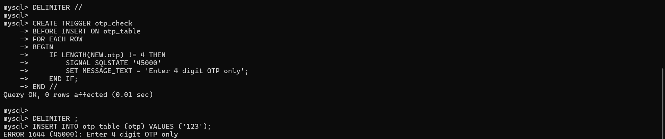
- View (Student basic details):
CREATE VIEW student_view AS
SELECT reg_id, student_name
FROM student;
Use view:
SELECT * FROM student_view;
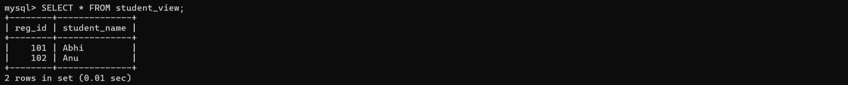
- Exception Handling in MySQL (Using SIGNAL):
DELIMITER //

CREATE PROCEDURE check_regid(IN rid INT)
BEGIN
IF rid <= 0 THEN
SIGNAL SQLSTATE '45000'
SET MESSAGE_TEXT = 'Register ID must be greater than zero';
ELSE
SELECT 'Valid Register ID' AS Status;
END IF;
END //

DELIMITER ;
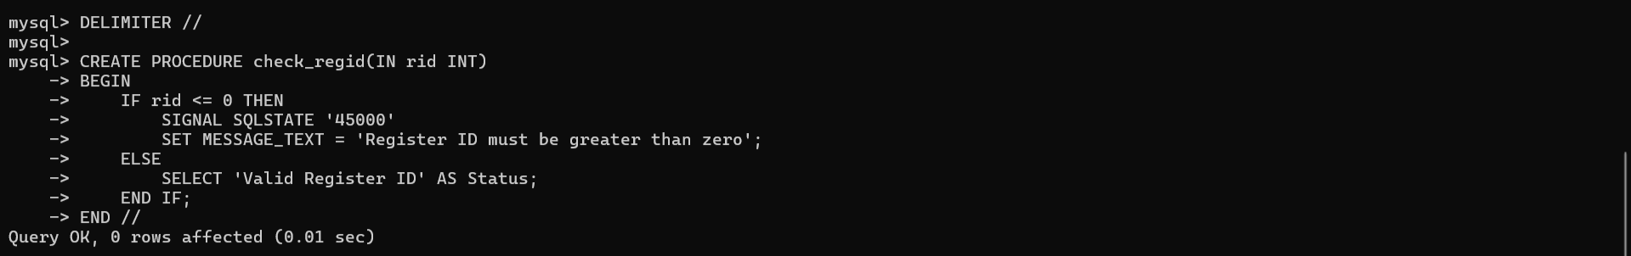
Call:
CALL check_regid(-1);

